Xbox System Software Overview
If you have questions or comments, contact your account manager.
Overview
The system software of the Xbox™ video game system from Microsoft provides a small, fast, safe, robust, and customizable environment in which developers can create great games for Xbox. It provides a set of useful common services, such as networking and file system input/output (I/O), that game developers can take advantage of so that they can focus on creating great games. The system software also provides an attractive, easy-to-use interface for functions other than running games, such as playing audio CDs or configuring the Xbox console. The Xbox system software has three components:
- The Xbox game system read-only memory (ROM)
- The Xbox Title Libraries (XTL)
- The Xbox Dashboard
Xbox Game System ROM
The ROM of the motherboard on the Xbox console provides the following system-software services:
- Hardware abstraction layer (HAL)
- Driver model
- Hard disk driver
- DVD driver
- FAT32-based file system
- UDFS-based file system
- Copy-protection support
- Certificate/signature validation
- Basic application services, such as the application loader, memory management, and threading
Software System Kernel
The software system kernel is based on Microsoft® Windows® 2000. However, many features of Windows 2000 are not included in the Xbox system software, including those related to running on multiple hardware platforms or running multiple processes at once. For more information about unsupported Microsoft® Win32® APIs, see Win32 API.
There is no support for code running in user mode (Ring 3) on Xbox. All code executes in kernel mode (Ring 0). Only one process runs at a time, and that process may support multiple threads. There is no Windows 2000 desktop or windowing user interface (UI); the UI is provided by the individual games titles or, if no game is running, by the Xbox Dashboard.
Power Up
When the user turns on the console, the system software is decompressed out of ROM into random access memory (RAM). Once in RAM, the system software initializes the hardware (DVD, audio, video, and so on).
After the hardware has been initialized—approximately one second after the machine is turned on—the system software displays the boot graphic and plays the startup sound.
Media Detection
Upon power up and during the display of the startup graphic and the playing of sound, the system software attempts to determine what type of media is in the DVD drive. If it determines that the media is a game, it checks the signature of the game to verify that it is an authentic copy, then launches the game. If the media is not a game, the Xbox Dashboard is run as follows:
- Audio CDs are played by the Xbox Dashboard audio player.
- If unsupported media is present, an invalid content message displays and the Xbox Dashboard UI for game system configuration runs.
- If no media is present, the Xbox Dashboard UI for game system configuration runs.
For more information, see the later topic Xbox Dashboard.
Supported media are CD, DVD, CD-RW, or DVD-R. There is no CD-R support. Note that games are published on DVD.
Game Launch
While the game image is streamed into memory, the system software checks the signatures of each section of the image on the fly.
Once the game image is in memory, the system software starts the game. At this point, the kernel acts in conjunction with the XTL to provide all of the basic services for the game.
The Xbox game image format is not compatible with other executable systems, such as the Windows 2000 executable format. The Xbox game image must be loaded by the Xbox system software. Unlike standard Windows 2000 applications, there are no dynamic-link library (DLL) loads, no fix ups, and so on.
Xbox Title Libraries
The Xbox Title Libraries (XTL) define the programming model used to develop software for Xbox. They consist of all libraries provided with the Xbox Development Kit, which are linked into every title written for the Xbox console, including the following:
- Subset of the Microsoft Win32 APIs
- Subset of the Microsoft® DirectX® 8.0 APIs
- Subset of Microsoft® C Runtime (CRT) APIs
- Xbox video driver
- Xbox audio driver
- Xbox input driver (based on universal serial bus)
- Xbox memory unit support
- Xbox network stack: media access control, Network Driver Interface Specification (NDIS), Transmission Control Protocol/Internet Protocol (TCP/IP), Windows Sockets (Winsock)
The primary programming model for Xbox will be defined by the XTL. Because the XTL is partitioned into distinct libraries (modular), game developers can choose which libraries are appropriate for their title. For example, if a game will support online play, the developers include the Xbox networking library with their game. If no online play support is planned, they do not include the Xbox networking library. While some support is implemented in the kernel of the system software in the Xbox game system ROM (for example, file system support, threading, memory management), the libraries to access these features are exposed through the XTL.
All Xbox-compatible code runs at Ring 0 on Xbox, which means that the XTL is implemented in kernel mode and that all games run in kernel mode. However, most Xbox Title Libraries will be signature-compatible with their user-mode implementation. From a developer's perspective, the Xbox Title Libraries function as they would in user mode. Kernel mode results in faster performance at run time.
Win32 API
The Xbox system software supports a subset of the Win32 APIs. Some omissions from the standard Win32 environment include portions of the User Interface services, Graphics Device Interface (GDI) support, or component services such as OLE. Any essential libraries are included as needed.
Windows 2000 services not available in the Xbox system software include the following:
- Services
- Plug and play
- Additional hardware enumeration
- Hot docking
- All unsupported drivers
- Power management
- Virtual memory (paging)
- Multiple-process support
- Multiple-processor support
- Windows NT file system (NTFS)
Graphics
The primary graphics libraries for the Xbox game system are Microsoft® Direct3D®. Direct3D for Xbox is based on DirectX 8.0 and is implemented using a custom driver specific to the final NVIDIA chipset and video adapter. The graphics libraries for Xbox are compatible with DirectX at the libraries layer while providing the thinnest, fastest-possible access to the video hardware. The Direct3D driver is combined with the HAL to create a completely monolithic driver implementation.
The drivers support both NTSC and PAL TV output. Moving Picture Experts Group (MPEG) video is supported.
Input
The Xbox controller connections and external peripheral connection are electrically universal serial bus (USB) ports with an Xbox proprietary connector. Xbox implements USB drivers for any possible peripherals connected to the Xbox console. Only full-speed USB is supported.
Libraries specific to Xbox are used for development with most Xbox controllers. Xbox-licensed game system controllers should work without an additional driver. This assumes that Xbox controllers do not introduce any new axis or capability not covered by the standard Xbox libraries.
Audio
The audio libraries for Xbox are based on subsets of Microsoft® DirectSound® and Microsoft® DirectMusic®, from DirectX 8.0. Audio streaming is not based on Microsoft® DirectShow®, however. Instead, Xbox-specific audio streaming libraries are implemented for high quality CD playback without skipping and without undue use of the CPU. The following features are supported by the Xbox audio libraries:
- Microsoft® Windows Media™ Audio (WMA) files
- WAV files
- MIDI playback
- Interactive music
- 3-D sound
There is no support for Red Book audio.
Video
As with audio streaming, the video streaming libraries for Xbox are not based on DirectShow. Instead, Xbox-specific video streaming libraries will be implemented.
Networking
The XTL includes networking services for online capabilities, including TCP/IP and Winsock support. If online connectivity is not wanted for a game, the Xbox networking libraries should not be linked and included with the game title.
A subset of Microsoft® DirectPlay® will be supported. For more information, see the “Xbox DirectPlay” specification.
New Xbox Services
The Xbox system software includes new services that are specific to Xbox and that are not based on any existing Win32 or DirectX libraries, including the following:
- Virtual keyboard support for simplified text entry and game-specific skins
- Online user accounts
- Multiplayer matchmaking
- Hard disk management to allow game titles to use the Xbox hard disk for configuration stores, cache space, and so on
Xbox Dashboard
The Xbox Dashboard is an application, stored on the Xbox hard disk, that is the UI when a game is not running in the Xbox console. It provides five services:
- CD player
- System configuration utilities for Xbox
- Online connectivity and configuration utilities
- Saved game management
- Error handling
Initially, the UI of the Xbox Dashboard offers four choices to the user:
- Games
- Music
- Settings
- Memory
CD Player
The CD player can be configured for AutoPlay (so that an audio CD will play when the user inserts it into the Xbox console and powers up) or for manual control, which presents controls for pause, skip, playlist management, and so on.
Xbox Console Configuration
The Xbox console configuration utility is part of the Xbox Dashboard and presents the UI for all preferences and settings for the Xbox console, including the following:
- Video configuration
- Audio configuration
- Parental control
- Date and time
- Language
Online Connectivity
Online connectivity presents the user interface that allows a user to get an Xbox Zone online account.
Saved Game Management
Saved game management presents the UI for hard disk and Xbox memory unit management, including saving, deleting, and copying games.
Error Handling
The Xbox Dashboard handles software errors that occur during system-boot execution of the Xbox console. However, hardware errors (for example, hard disk failure) are handled by the Xbox system software. Game errors are handled not by the Xbox Dashboard, but by the game software.
Appendix A
The following diagrams show the behavior of the Xbox console in its various boot states and describe its various boot sequences.
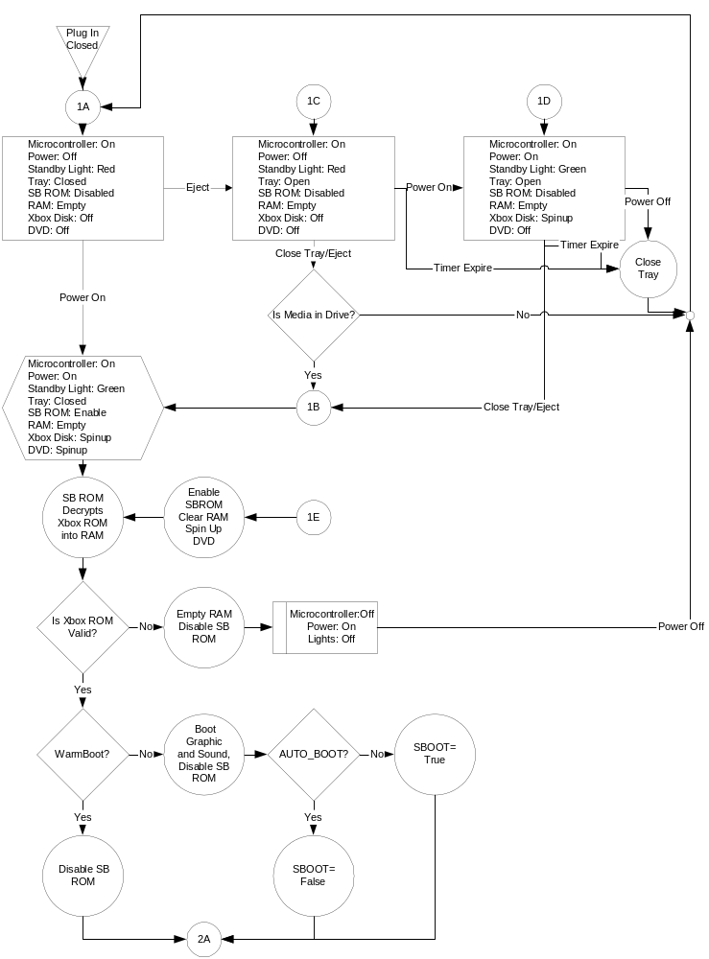
Figure 1 Initial boot states

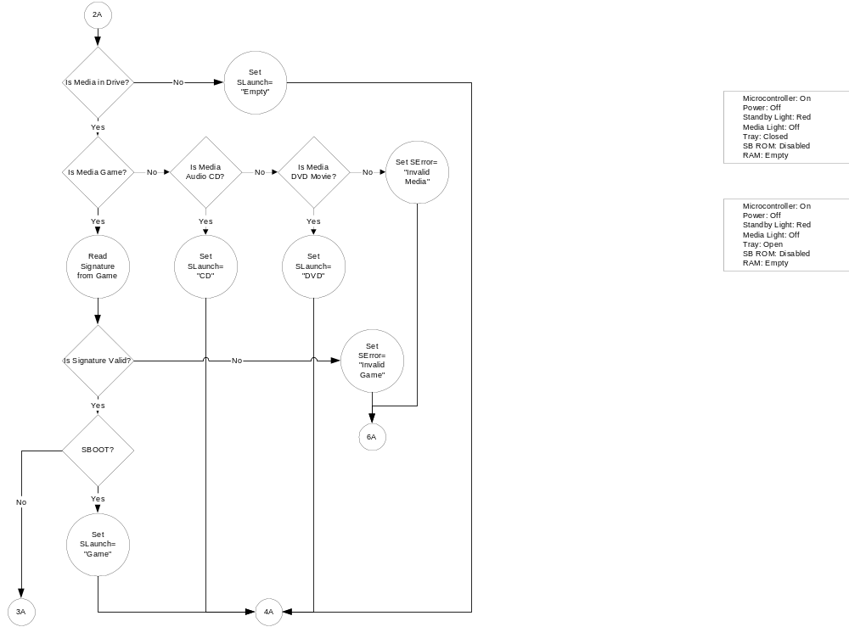
Figure 2 Media detection

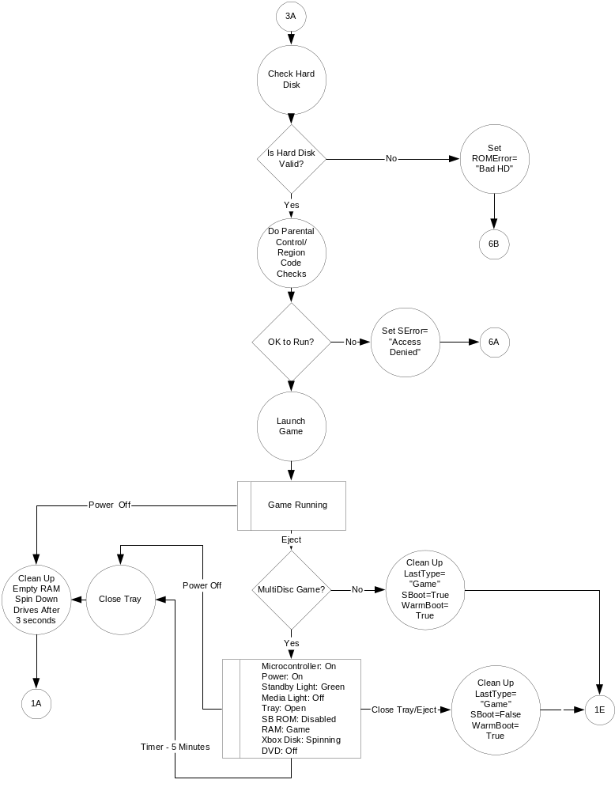
Figure 3 Game launch

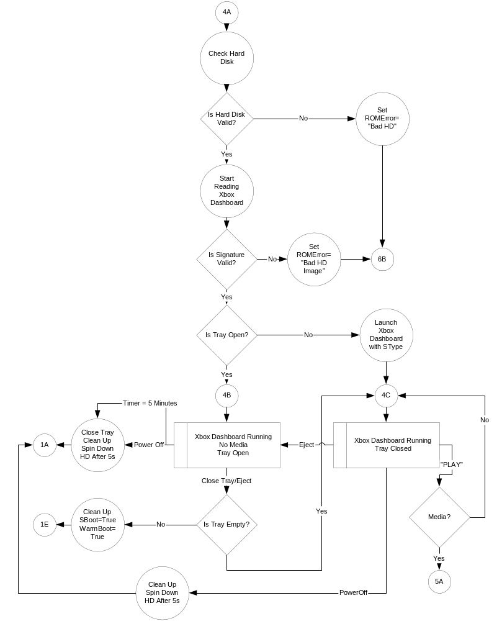
Figure 4 Xbox Dashboard

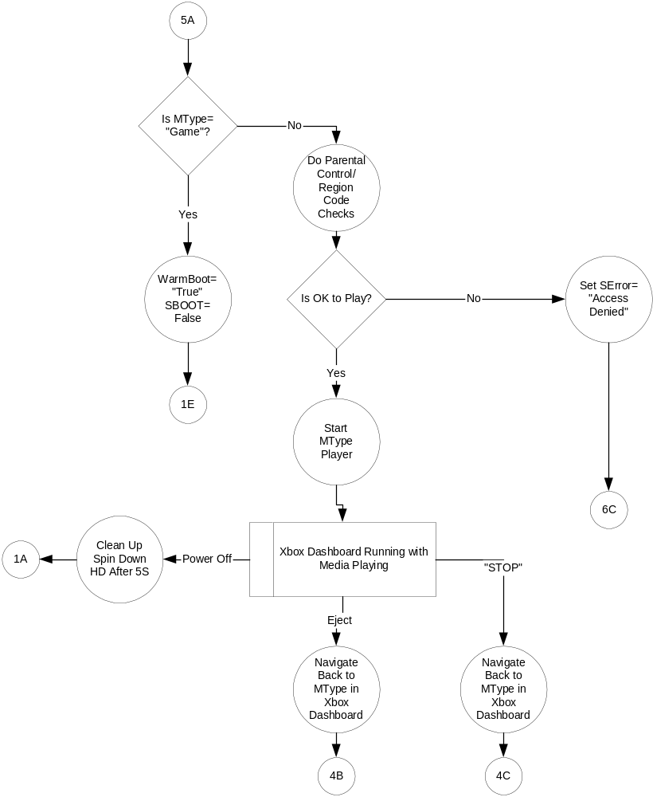
Figure 5 Xbox Dashboard—media play

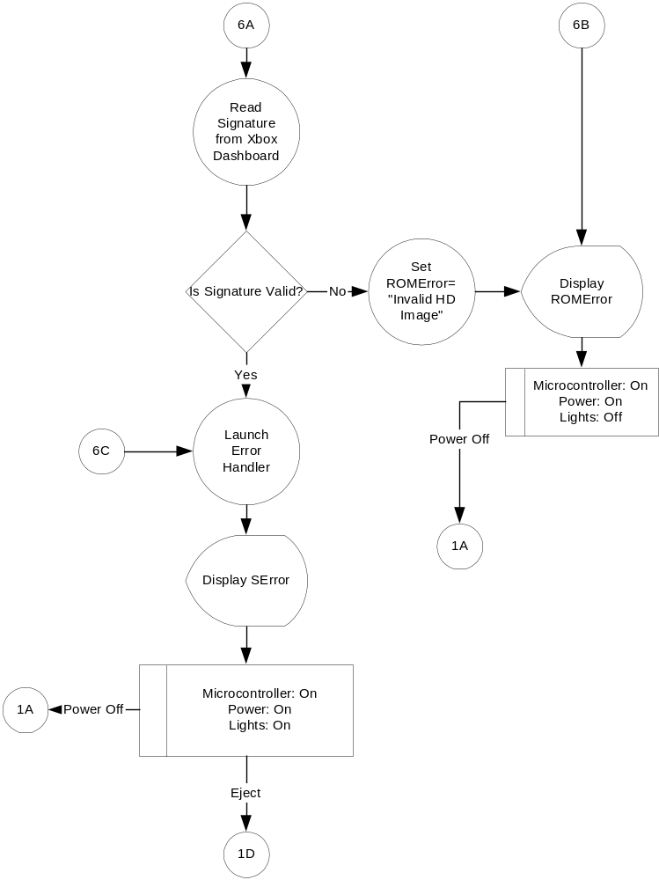
Figure 6 Error handling

